Method Statement - Aerial Rig and Water Bowl

Overview

The aerial rig is an aluminium quad rig with a central rigging bar - there are 3 aerial points. It is manufactured in the UK via Firetoys and complies with all necessary UK safety regulations, rated for dynamic work and two people per time.

The water bowl is manufactured in the UK via Boris Murzak and is made of aluminium and perspex.

Aerial rig build
Rig is unloaded and assembled first. It arrives in sections and is carried in pairs and assembled by our team. The rig does not require any additional ballasts or sandbags but does require a firm level surface and a 8x8m clear area to build.

The rig has three height options as can be seen in the diagram below. This show can be performed with the rig at its medium height for an easier build.

- Full height: 6.5m (H) x 8.5m (W) x 8.2m (L)
- Medium height: 5.5m (H) x 6.8m (W) x 6.4m (L)
- Low height: 4.5m (H) x 5.4m (W) x 4.8m (L)

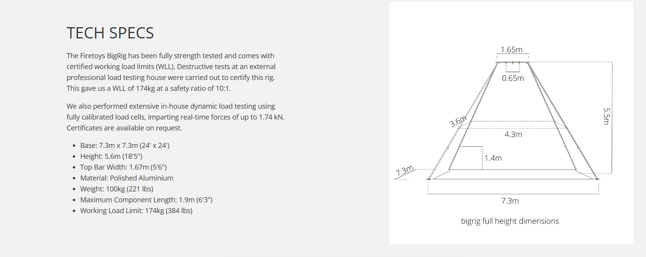

We will also have mermaid activities outside the rig during performances (clothes rail (with sandbags over the feet), Siren’s Mirror (our AR station) and mermaid meet and greets that audiences can come to take pictures with on an adapted gorilla truck)

For health and safety reasons a steward is required outside the barrier area to keep works area clear.

There will be a pre-tested and inspected pulley system in place.

Water bowl

Please skip ahead to Get in/ get out if not using the waterbowl.

The water bowl is made from aluminium and perspex and fits 200 gallons approx. It is 1.5m diameter and 0.75m h (height of the bowl, not including the stand). It comes in two sections and will be removed from the van in pieces - the stand and then the bowl itself. The stand will be placed under the built rig by the full team, with the bowl added on top ready to be filled. Weight when completely full: approx 800kg

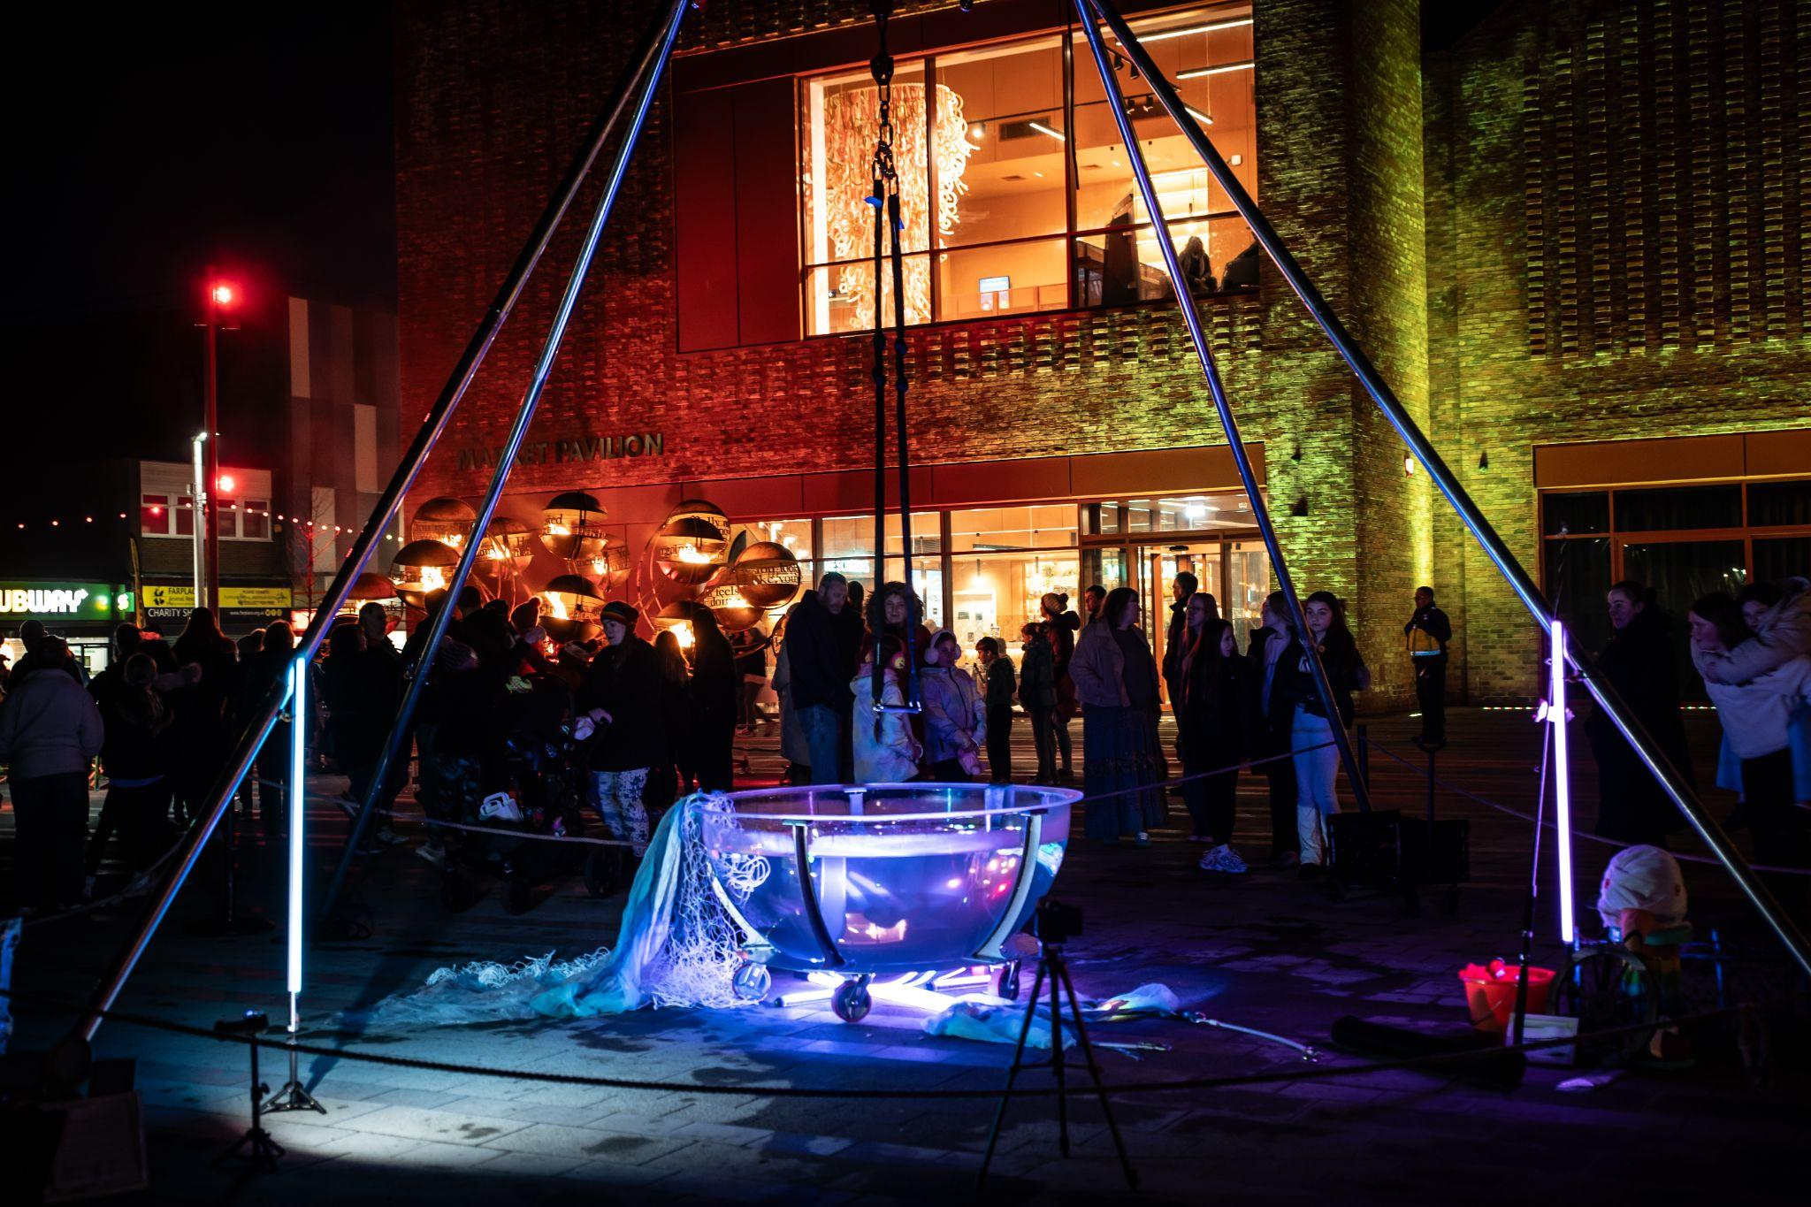
Bowl 1.5m diameter x 0.75m depth
Stand heights 0.25m, 0.5m up to 0.75m
Full (approx) 1000 litres
Weight when full 1000kg
Weight including stand and frame 1100kg (max)

Filling the bowl
Helpful info required from venue - distance from water supply and flow rate of the water
This determines our fill time.

We have hoses of varying lengths if we have access to an outdoor approved water supply.
If the flow rate is slow, we can provide water carriers that can be filled in pairs from a water supply and carried back to the bowl via our festival trolley (15 stone load capacity). Weight of water per butt will not exceed 5 stone and will be lifted in pairs into the bowl by Aria crew who are practised in filling the bowl. This will require 40 water butts to fill the bowl to max capacity. If pushed for time, the bowl can be filled to 75% its max capacity and still provide the required aesthetic.

Heating the bowl
We have a battery operated water heater that will be placed inside the bowl to take the edge off the cold water

Draining the bowl / de-rig
Bowl will be drained with hoses to a nearby drain or via our water butts and moved in pairs on trolley to drainage area. Bowl will be dismantled by our team and replaced in the van before the rig is brought down as a team and carried in pairs to the van.

Get in / get out times

Get in / Out water bowl and rig:
Get in: 2hours
Get out Time: 1h 30mins
Vehicle Access: van for unloading and loading, nearby parking.

Get in / rig only:
Get in: 1hour max
Get out Time: 30mins
Vehicle Access: van for unloading and loading, nearby parking.

Additional Info:
Rig inspected before and after each erection.
No one to assist with rigging unless agreed with company
No access to area while structures are being lifted or brought down.

Weather

Wind - The rig and bowl is not fit for use with winds beyond 25mph (as certified by manufacturer). Our preferred safety is 20mph or under.
Rain - acts can be performed in light rain (with equipment wiped down to avoid any slippage) or adapted to harness work e.g. no trapeze/hoop/net.
Medium rain beyond 2.6mm per/hour results in non-performance
Ice - aerial component not to be performed in icy weather but adapted in-water elements are possible

Disclaimer:
Information relating to the mechanical and structural characteristics of the rig are taken from the technical documentation supplied by the manufacturer.

