Method Statement - Aerial Rig and Water Bowl

Overview

The aerial rig is an aluminium quad rig with a central rigging bar. It is manufactured in the UK via Firetoys and complies with all necessary UK safety regulations.

The water bowl is manufactured in the UK via Boris Murzak and is made of aluminium and perspex.

Aerial rig build
Rig is unloaded and assembled first. It arrives in sections and is carried in pairs and assembled by our full team of 4 people to ensure ease of lifting. The does not require any additional ballasts or sandbags but does require a firm level surface and a 8x8m clear area that is cordoned off to members of public.

The rig has three height options as can be seen in the diagram below. This show can be performed with the rig at it’s mid-height setting (4.5m H) for an easier build. The rig requires a 7.3m x 7.3 footprint but we have specified 8x8m as we will also have some mermaid activities outside the rig footprint during the day performance (clothes rail and a mermaid audience can come to take pictures with on a dolly cart)

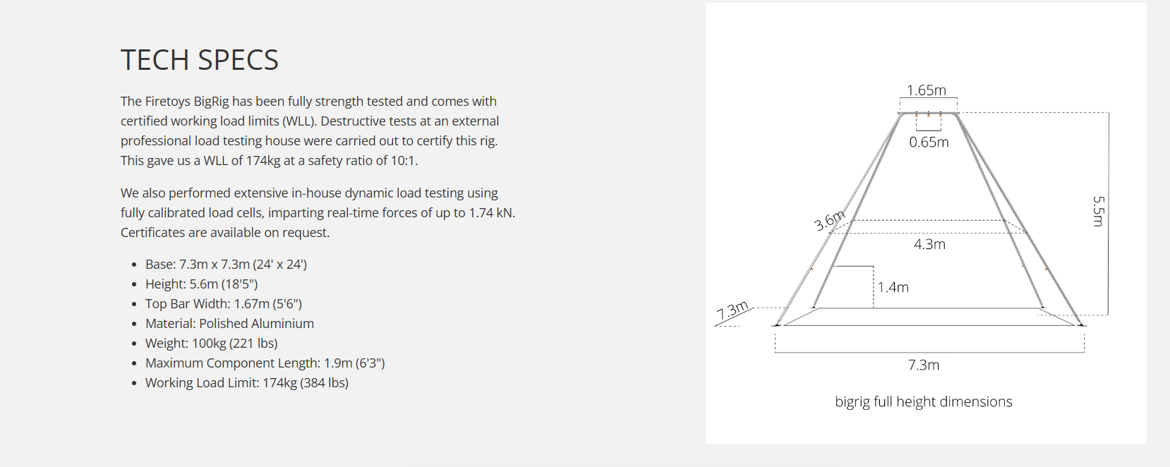

For health and safety reasons a steward is required outside the barrier area to keep works area clear.

There will be a pre-tested and inspected pulley system in place.

Water bowl
The water bowl is made from aluminium and perspex and fits 200 gallons approx. It is 1.5m diameter and 0.75m h (height of the bowl, not including the stand). It comes in two sections and will be removed from the van in pieces - the stand and then the bowl itself. The stand will be placed under the built rig by the full team, with the bowl added on top ready to be filled. Weight when completely full: approx 800kg
Dry-hire job, no water included

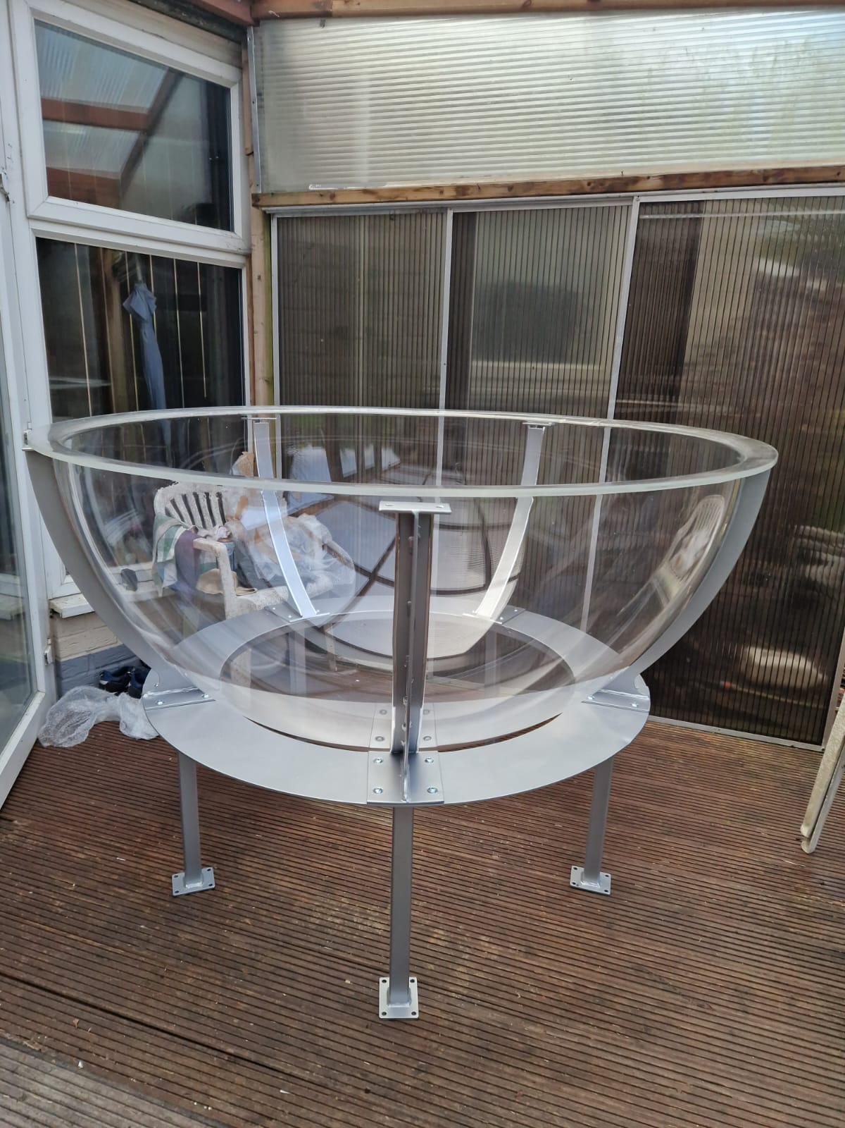
Bowl 1.5m diameter x 0.75m depth
Stand height 0.5m

Filling the bowl
This is a no-fill job and the bowl will be filled with gauzy fabrics, bubbles and sequins to catch the light

PA
We have an adequate PA system - Vonyx PA with mics, battery-powered and self-contained
1000W
It would be helpful not to have competing sound / stage directly at the same time during our act

Show time / offer
For BBC 1 introducing - a 6 min act incorporating dance and aerial net with a fisherman and mermaid duet
Up to 3 hours aerial tasters, crafts, tail try-ons, interactive become a mermaid QR code station and mermaid meet and greet

Get in / Out:
Get in: 90 mins approx
Get out Time: 1h
Vehicle Access: van for unloading and loading, nearby parking.

Additional Info:
Rig inspected before and after each build.
No one to assist with rigging unless agreed with company
No access to area while structure is being lifted or brought down (we can however de-rig safely within our footprint)

Weather
Wind - The rig and bowl is not fit for use with winds beyond 25mph (as certified by manufacturer). Our preferred safety is 20mph or under.
Rain - acts can be performed in light rain (with equipment wiped down to avoid any slippage) or adapted to harness work e.g. no trapeze/hoop.
Medium rain beyond 2.6mm per/hour results in non-performance
Ice - aerial component not to be performed in icy weather but adapted in-water elements are possible

Disclaimer:
Information relating to the mechanical and structural characteristics of the rig are taken from the technical documentation supplied by the manufacturer.

